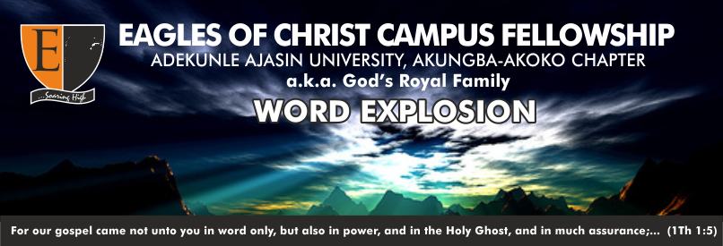

**THEME: THE SPIRIT OF GOD TEL: 08144734638**

**TOPIC: HEAVEN: HOPE OF ALL SAINTS 0703850705**

**TEXT: REV. 20:11-15**

**SPEAKER: PST. ADODO TOBI MICHAEL**

**DATE: 13TH AUGUST, 2019. Email: eccfaaua@yahoo.com**

**Golden Text: Rev.20:8**

A

ll glory to God, the father of the Lord Jesus Christ, who loved us and gave up His only begotten son to die and put an end to the enmity between Him and humans. (**Isa.59:1-2**). God was in Christ, reconciling all men to Himself (**2cor.5:21**).

The bible talks about heaven which is the hope of all saints. **Matt.24:30-51.** The bible also recorded that the sinners shall have their place in the lake which burneth with fire and brimstone. **Rev.21:5-8**

Heaven or Hell is the final destination of everyone, where to belong depend on the decision you make today. God has created us a free moral agent to choose our place of eternity, (**Deut. 30:15-19)** today, what will your choice be? **HEAVEN OR HELL**? Though, some might profess or claim that they are **BORN AGAIN, BUT IN REALITY THAT ARE BURNT AGAIN**. What a pity!

**LET'S LOOK AT THE FOLLOWING SUB-TOPICS TOGETHER:**

**1. Description Of Heaven And Hell**

* **HEAVEN -->** John 14:1-5, Rev.21:9-27
* **Hell-->** Rev.21:8, Rev.20:8-10

**2. Conditions Necessary For Believers Hope.**

* **BE BORN AGAIN a**nd not burnt again. Jhn.3:1-3
* **HOLINESS** though not a big deal, but a real deal. 1pet.1:4, 2 Thes. 2:10
* Drop all **FILTHINESS.**Heb.12:.1, Jam.1:21
* **BELIEVE i**n God. Jhn. 14:1, 11-12, Matt.17:20
* Have **FAITH.** Heb.11:5-6, Jam.2:17-26

Believers are currently engaged in spiritual battle's against sins, Satan and his agents, flesh, sickness and sorrows. **Eph.6:10-15.** Jesus has given us victory; He has defeated the enemies on our behalf. Victory is sure for us today.

Brethren, I would not have you ignorant, soul that sinneth shall die. Pray, that on the streets of glory will I lift my voice, cares all past, **HOME AT LAST!**

**Hymn**

**OH I WANT TO SEE HIM**

1. **As I journey through the land, singing as I go,  
   Pointing souls to Calvary—to the crimson flow,  
   Many arrows pierce my soul from without, within;  
   But my Lord leads me on, through Him I must win.**

***Refrain:  
Oh, I want to see Him, look upon His face,  
There to sing forever of His saving grace;  
On the streets of glory let me lift my voice,  
Cares all past, home at last, ever to rejoice.***

1. **When in service for my Lord dark may be the night,  
   But I’ll cling more close to Him, He will give me light;  
   Satan’s snares may vex my soul, turn my thoughts aside;  
   But my Lord goes ahead, leads whate’er betide.**
2. **When in valleys low I look toward the mountain height,  
   And behold my Savior there, leading in the fight,  
   With a tender hand outstretched toward the valley low,  
   Guiding me, I can see, as I onward go.**
3. **When before me billows rise from the mighty deep,  
   Then my Lord directs my bark; He doth safely keep,  
   And He leads me gently on through this world below;  
   He’s a real Friend to me, oh, I love Him so.**

***ALL CORRESPONDENCE TO THE BIBLE STUDY UNIT VIA THE SECRETARY***